**Eclipse surtcuts**

**30 Useful Eclipse Keyboard Shortcuts for Java Programmers**

Here is my list of 30 chosen Eclipse IDE keyboard shortcuts for Java developers. It's useful for both core Java developer and Java web application developer using Eclipse IDE for web development.

1)      **Ctrl + Shift + T** for finding a class even from a JAR file

This keyboard shortcut in Eclipse is my most used and favorite shortcut. While working with a high-speed trading system which has a complex code, I often need to find classes with the just blink of the eye and this Eclipse keyboard shortcut is just made for that. No matter whether you have a class in your application or inside any JAR in the workspace, this shortcut will find it.

2)      **Ctrl + Shift + R**for finding any resource (file) including config xml files

This is similar to above *Eclipse shortcut* with the only difference that it can find out not only Java files but any files including XML, configs, and many others, but this eclipse shortcut only finds files from your workspace and doesn’t dig at the JAR level.

3)      **Ctrl + 1**for quick fix

This is another beautiful Eclipse shortcut which can fix up any error for you in Eclipse. Whether it’s missing declaration, missing semi-colon, or any import related error this eclipse shortcut will help you to quickly sort that out.

4)      **Ctrl + Shift + o** for organize imports

Another Eclipse keyboard shortcut for fixing missing imports. Particularly helpful if you copy some code from other file and what to import all dependencies.   
  
You can further see [The Eclipse Guided Tour - Part 1 and 2](https://pluralsight.pxf.io/c/1193463/424552/7490?u=https%3A%2F%2Fwww.pluralsight.com%2Fcourses%2Feclipse-guided-tour-part1) on Pluralsight to learn more about code formatting shortcuts in Eclipse.

[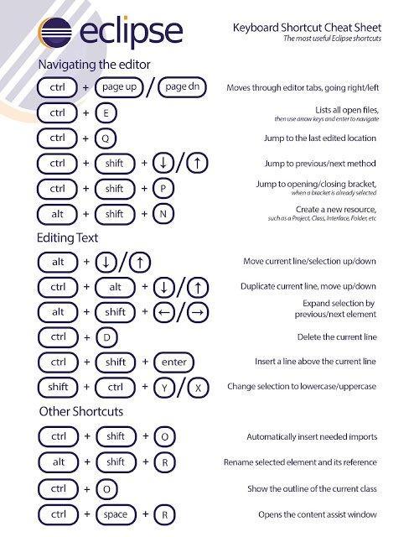](https://pluralsight.pxf.io/c/1193463/424552/7490?u=https%3A%2F%2Fwww.pluralsight.com%2Fcourses%2Feclipse-guided-tour-part1)

Btw, you would need a Pluralsight membership to access this course, which costs around $29 monthly or $299 annually. I have one and I also suggest all developers have that plan because Pluralsight is like NetFlix for Software developers.  
  
It has more than 5000+ good quality courses on all latest topics. Since we programmers have to learn new things every day, an investment of $299 USD is not bad.  
  
  
Btw, it also offers a [**10-day free trial**](http://pluralsight.pxf.io/c/1193463/424552/7490?u=https%3A%2F%2Fwww.pluralsight.com%2Flearn) without any obligation which allows you to watch 200 hours of content. You can watch this course for free by signing for that trial

**Eclipse Shortcut for Quick Navigation**

In this section, we will see some eclipse keyboard shortcut which helps to quickly navigate within the file and between file while reading and writing code in Eclipse.

7) **Ctrl + o** for quick outline going quickly to a method

9) **Alt + right**and **Alt + left** for going back and forth while editing.

12) **Alt + Shift + W  to show a class**in package explorer

13) **Ctrl + Shift + Up**and down for navigating from member to member (variables and methods)

15) **Ctrl + k**and **Ctrl + Shift +K**for find next/previous

16) Go to a type declaration: **F3**,This Eclipse shortcut is very useful to see function definition very quickly.  
  
Apart from these keyboard shortcuts, learning how to debug Java program in Eclipse is also a skill. There are so many debugging tools and features available in Eclipse, which many Java programmer doesn't know e.g. conditional debugging, hit count, and remote debugging.   
  
If you really want to become a good Java developer I suggest you improve your debugging skill and if you need some help with [Eclipse Debugging Techniques And Tricks](https://click.linksynergy.com/fs-bin/click?id=JVFxdTr9V80&subid=0&offerid=323058.1&type=10&tmpid=14538&RD_PARM1=https%3A%2F%2Fwww.udemy.com%2Feclipse-debugging-techniques-and-tricks%2F) is the best place to start with.

[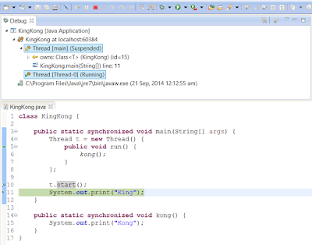](https://click.linksynergy.com/fs-bin/click?id=JVFxdTr9V80&subid=0&offerid=323058.1&type=10&tmpid=14538&RD_PARM1=https%3A%2F%2Fwww.udemy.com%2Feclipse-debugging-techniques-and-tricks%2F)

**Eclipse Shortcut for Editing Code**

These Eclipse shortcuts are very helpful for editing code in Eclipse:

5) **Ctrl + /**for commenting, uncommenting lines and blocks, see [here](http://javarevisited.blogspot.com/2012/10/eclipse-shortcut-to-remove-all-unused-imports-java.html) for live example.

6) **Ctrl + Shift + /** for commenting, uncommenting lines with block comment, see [here](http://javarevisited.blogspot.com/2012/12/eclipse-shortcut-to-comment-uncomment.html)for example.

8) Selecting class and pressing **F4** to see its Type hierarchy

10) **Ctrl + F4 or Ctrl + w** for closing current file

11) **Ctrl+Shirt+W for** closing all files.

14) **Ctrl + l**go to line

16) Select text and press **Ctrl + Shift + F** for formatting.

17) **Ctrl + F** for find, find/replace

18) **Ctrl + D** to delete a line

19) **Ctrl + Q** for going to last edited place

You can further see  [Eclipse IDE for Beginners: Increase Your Java Productivity](https://click.linksynergy.com/fs-bin/click?id=JVFxdTr9V80&subid=0&offerid=323058.1&type=10&tmpid=14538&RD_PARM1=https%3A%2F%2Fwww.udemy.com%2Fluv2code-eclipse-ide-for-beginners%2F" \t "_blank) to find live examples for most of these shortcuts. It's a free course on Udemy so you don't need to pay anything.

Read more: <https://javarevisited.blogspot.com/2018/07/top-30-eclipse-keyboard-shortcuts-java-programming.html#ixzz5nbOy0ShX>